David Jones media

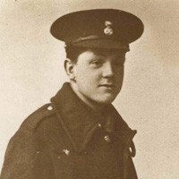

**The Royal Welch Fusiliers Musuem / The David Jones Literary Estate**

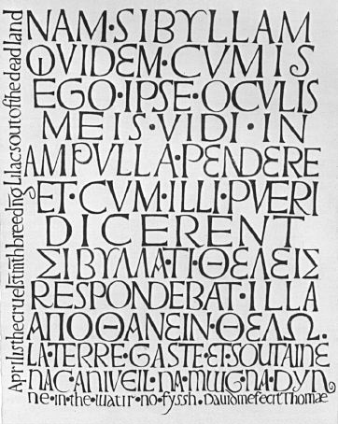

*Nam Sybillam* (1958); opaque watercolour on an under-painting of Chinese white. Reproduced as frontispiece in *Symposium for T.S. Eliot’s Seventieth Birthday* (1958); Estate of Valerie Eliot

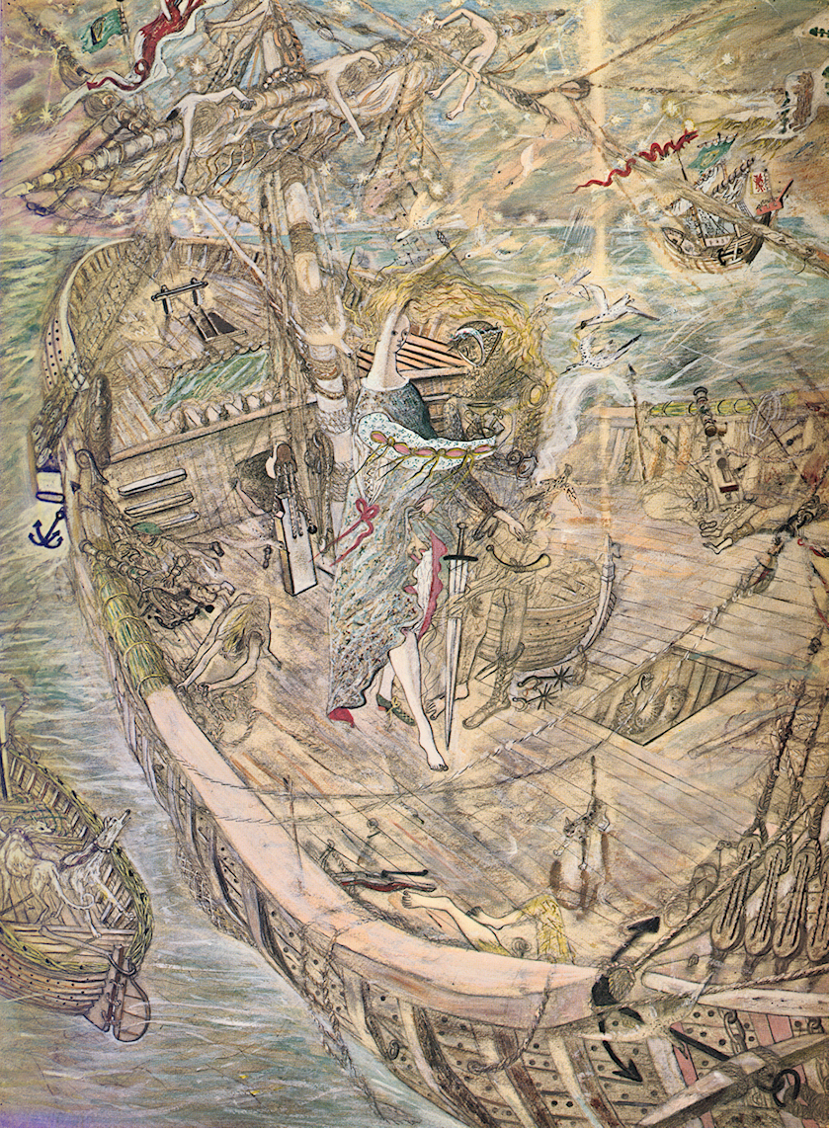

*Trystan ac Essyllt* (1962)

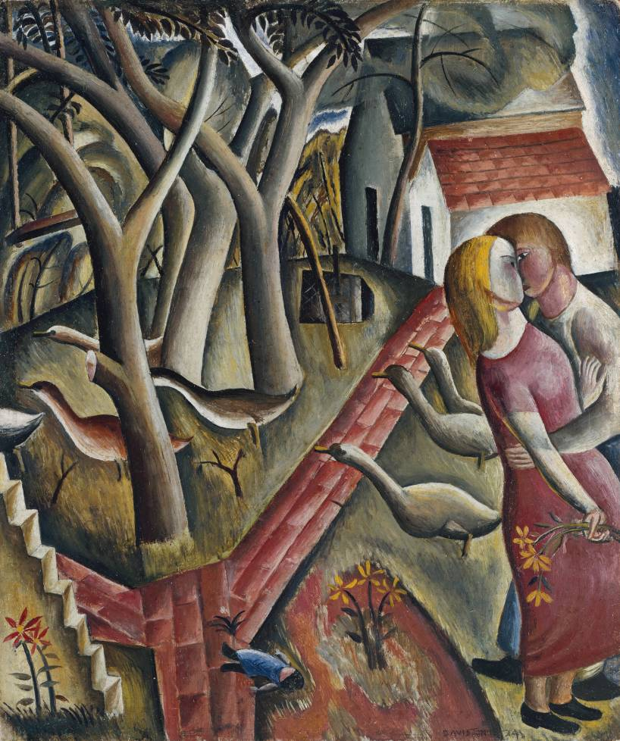

David Jones, *The Garden Enclosed* (1924), oil paint on wood; Tate Britain (Presented by the Trustees of the Chantry Bequest, 1975); <http://www.tate.org.uk/art/artworks/jones-the-garden-enclosed-t02013>

caption: *the two figures to the right of this scene represent the artist and Eric Gill’s daughter, Petra to whom Jones was briefly engaged and would paint and draw several times.*